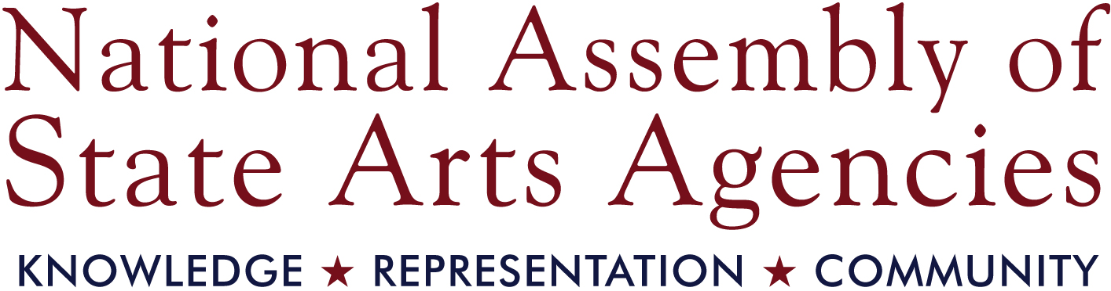 | NEWS RELEASE  FOR IMMEDIATE RELEASE  October 14, 2015  CONTACT: Sue Struve  202-347-6352 x109  sue.struve@nasaa-arts.org

NASAA Welcomes 2016 Board Members

WASHINGTON, D.C. — The National Assembly of State Arts Agencies (NASAA) is pleased to announce the election of five new members to its board of directors. As part of a rigorous national nomination process, state arts agencies elected these outstanding leaders last week at the NASAA 2015 Leadership Institute in Salt Lake City, Utah. Each will serve a two-year term.

Monica Okada Guzman, Chair, Guam Council on the Arts & Humanities Agency
As chief executive officer and managing partner of the Galaide Group, Monica Guzman is responsible for overseeing the creation and coordination of media campaigns, public outreach events and special projects. Guzman's public service experience spans 13 years with the Government of Guam at the Office of the Governor under multiple administrations, coordinating and managing community outreach programs, constituent and media communications, research programs, and special projects. She is secretary for the 2016 Festival of Pacific Arts Coordinating Committee and chairs the festival's Programming Committee. Guzman is a board member of Pacific Islanders in Communication and president of the Guam Nikkei Association. Memberships include the Guam Visitors Bureau, Guam Hotel and Restaurant Association, Guam Contractors Association, Guam Chamber of Commerce and U.S. Women's Chamber of Commerce. She served as administrative director of the Guam National Olympic Committee for 10 years and is past chairperson of the board for Guam's public television station, KGTF Channel 12. She received the 2010 Guam Women's Club Women of Movement certificate and was chosen as the 2011 Small Business Administration's (SBA) Women in Business Champion and for the Secretary of Defense Employer Support Freedom Award. In 2014, she was named the SBA's Minority Business Champion and was nominated as Business Woman of the Year. Guzman writes a weekly column in the local daily.
Matthew Harris, Division Administrator, Iowa Arts Council
Matthew Harris has served as administrator of the Iowa Arts Council, a division of the Iowa Department of Cultural Affairs, since 2011. He also serves as a member of the Iowa Department of Cultural Affairs leadership team, which in addition to the Iowa Arts Council, encompasses the State Historical Society of Iowa, State Historic Preservation Office, State Historical Museum & Research Centers, State Records and Archives, and Produce Iowa - State Office of Media Production. A Cedar Falls, Iowa, native, Harris earned a degree in public relations from the University of Northern Iowa and worked in advertising for the Gallagher-Bluedorn Performing Arts Center before working in development for Des Moines Performing Arts, Iowa's largest nonprofit performing arts center, for more than six years. Harris is a 2013 Des Moines Business Record Forty Under 40 honoree, a recipient of the 2013 University of Northern Iowa Heritage Honours Distinguished Young Alumnus award and a graduate of the 2009-2010 Greater Des Moines Leadership Institute. He serves on the board of directors for Arts Midwest and on the national advisory board for the Governor Robert D. & Billie Ray Center at Drake University.

- more -
Karen Paty, Executive Director, Georgia Council for the Arts
Karen L. Paty has been working in the arts and community development for more than 15 years and was hired as executive director of Georgia Council for the Arts in 2011. As the agency's first hired director, she has executed multiple programs and projects, including guidance of an annual Governor's Award for the Arts and Humanities, inclusion of the arts in several tourism initiatives such as the Tourism Product Development grant, and development of The Art of Georgia, Georgia Council for the Arts's first exhibit featuring the work of state artists at the capitol. Upon being hired as executive director, she led the creation and implementation of a new five-year strategic plan that redefined the agency's mission and goals to better provide an opportunity for the arts to become an integral part of the lives of all Georgians. In recognition of her valuable contributions to the arts and to the state of Georgia, Paty was named one of the 2013 100 Most Influential Georgians by Georgia Trend magazine. Prior to her work at the Georgia Council for the Arts, Paty was associate director of civic engagement at Hands On Atlanta, a nonprofit organization dedicated to building community through volunteerism and civic engagement. She is a graduate of New York University, where she was a recipient of the university's President's Award for Service.
Omari Rush, Council Member, Michigan Council for Arts and Cultural Affairs
Omari Rush has a continually expanding role of service as both an artistic administrator and community leader, in part through his work as curator of public programs at the Ann Arbor Art Center, and previously as education manager at the University Musical Society. Additionally, he has served in an advisory role for numerous organizations of varying cultural and geographic scopes: as vice chair of the governor-appointed State of Michigan Council for Arts and Cultural Affairs, as a member of national advisory committees for the Kennedy Center for the Performing Arts and Association of Performing Arts Presenters, and as chair of the board of directors for the Ann Arbor Public Schools Educational Foundation. Rush earned degrees in music from the University of Michigan and Florida State University, and while his concert performances as a clarinetist are now infrequent, he fills his downtime with planning special events for friends (like shur! and the Fox Trot), reading (especially American Revolution literature) and eating kimchi (lots).
John Strickland, Council Member, West Virginia Commission on the Arts
John Strickland is president and major shareholder of Maynard C. Smith Construction Company, Inc., a Charleston, West Virginia, based commercial general contracting firm that specializes in new construction, renovation, and restoration of hospitals, office buildings and schools, as well as construction management. Strickland is active in construction associations, serving the local community and the state as past president and board member. He is also involved in civic and arts organizations, as a board member for 17 consecutive years of Sunrise Museum, which expanded to a new facility and became The Clay Center for Arts and Sciences of West Virginia; board member and incoming president of Edgewood Summit, a Charleston retirement and assisted living community; and a member of the West Virginia Commission on the Arts for more than eight years. Strickland is a graduate of the University of Florida in Gainesville, Florida.
"The current national climate calls for engaged leadership that is responsive to change," said NASAA CEO Pam Breaux. "These new NASAA board members bring skills and experience that will promote the value of public funding for the arts, foster the best interests of state arts agencies and advance NASAA. We are excited to begin work with this new team and we welcome their expertise and guidance."

- more -
For more information on NASAA's board members, visit NASAA 2016 Board of Directors.

The National Assembly of State Arts Agencies is the nonpartisan membership organization that unites, represents and serves the nation's state and jurisdictional arts agencies. Founded in 1968, NASAA represents their individual and collective interests, empowers their work through knowledge, and advances the arts as an essential public benefit. To learn more about NASAA and state arts agencies, visit www.nasaa-arts.org.

# # #

